City of Bloomington
Application for Building Permit and Water and Sewer Connections

Date Application #
Owner Name
Address

Telephone Number
Email Address
Address of Building Site
Utility Contractor Name __________________________________________License #____________________
I hereby certify that I have read and examined this application and know the same to be true and correct. All provisions of the law and ordinances governing this type of work will be complied with whether specified herein or not. The granting of this application does not presume to give authority to violate or cancel the provisions of any other state or local law regulating construction and/or the performance of construction.

Signature of Owner(s) Date
___________________________________________ Date
LOT REGULATION COMPLIANCE
☐ Lot Size: ½ acre minimum
☐ Frontage Width: 100 feet along a public right-of-way
☐ Side and rear setbacks: 10 ft. from property lines
☐ Ditch Setback: 25 feet from edge of ditch*
☐ Maximum Building Height: 35 feet
☐ Agricultural buildings, outbuildings, roll-off sheds or containers setbacks are the same as residential buildings. 100 feet of frontage width applies only to Residential buildings.
☐ Front Setback: 20 feet from the public right-of-way. Corner lots require the same setback on both sides.
☐ Variance -Issued only when physical attributes of the property warrant a change. Must submit an Application for Variance form.

*Owners wishing to locate a structure closer to an open ditch must obtain a letter of approval from the Bloomington Irrigation Company or private ditch owner.

CURRENT FEES
Residential and Agricultural Construction
- Structures under 200 sq. feet including roll-off sheds and containers $ 50.00
- Homes ………………………………………………………………………………………………………………………………$400.00
- Barns, sheds, additions, agriculture buildings and/or any other structure $250.00
- Change of Use (to residential use) $250.00
- Deck, Porch, Awning or attached lean-to $50.00
- Water Connection Fee (includes meter*) $3,500.00
- Sewer Connection Fee………………………… $3,000.00
- Variance Review Fee $250.00
- Penalty Fee $300.00
(Any work started prior to the posting of signed Colored Building Permit will be assessed a Penalty Fee including but not limited to Change of Use. Said penalty must be paid in addition to applicable permit fee.)
- Road Cutting Fee Retainer See **Road Damage Retainer Section
- Duplexes, Multi-Family Units and Commercial Construction TBD
(Subject to Individual Project Detail review)
- Fees to be submitted with application: one check for the Application fee, one check for Water and/or Sewer connection fees.
Fees related to building permits will not be deposited until permit has been approved except Variance Review Fee. Variance fee will be required prior to review.
Building Permits cannot be issued on illegally subdivided lots.
Building Permit Fees do not include Electrical, Mechanical, and Plumbing inspections. Those are regulated by the State of Idaho and are included in the individual permits obtained by the contractor/sub-contractors.
WATER:
- The City of Bloomington will provide all components for valves and connections, excluding poly pipe, to maintain consistency and to meet city specifications. (Meter housings, meter and valves associated the connections, as well as a “corp valve” will be made available upon payment of fees.)
- A City representative must be present to inspect the connections to the water main and the installation of the meter. Contact the City Clerk to schedule the inspection. Connection inspections must be scheduled 48 business hours in advance, Monday through Friday. See “Exhibit A.”
- The City may refuse to approve an application for service connection if it requires an extension of the city water main. The property owner requesting said service must submit engineering and construction plans which meet City specifications and agrees to pay all the costs of said engineering and installation, pending the city’s approval to service the connection.
- City must approve the location of the meter connection.
- Owner is responsible for all costs associated with connection from house to water main.
- Fees for water will begin on the first of the month following installation and inspection of meter.
- Once meter is set, owner is responsible for maintenance of water lines from meter to subject building or hydrant. City will be responsible for supply lines from water main to meter.
- Water meters are not allowed in driveways.

SEWER:
- A City representative must inspect the connection to the sewer main. Contact the City Clerk to schedule the inspection. Connection inspections must be scheduled 48 business hours in advance Monday through Friday.
- City must approve the location of the lateral connection.
- All piping materials must meet City specifications. (See “Exhibit B”)
- Applicant is responsible for all costs associated with installation of sewer connection.
- Fees for Sewer begin on the first of the month following installation and inspection.
- The City may refuse to approve an application for service connection if it requires an extension of the city sewer main. The property owner requesting said service must submit engineering and construction plans which meet the City’s specifications and agree to pay all costs of said engineering and installation, pending the City’s approval to service the connection.
Exception: Some properties in City of Bloomington may not have availability for sewer connection. Said availability shall be determined by the City Council. Owners that cannot be connected to the sewer system must provide a copy of their approved Septic Permit issued by Southeast Idaho Public Health.
**ROAD DAMAGE RETAINER:
- All applications or water/sewer connections requiring cutting through a gravel road will deposit a $1,500.00 retainer with the City. $1,200.00 will be refunded once the road has been compacted and returned to its original condition. Failure to return the road to its original condition within one year will result in a forfeiture of the retainer. If the cost to return the road to its original condition exceeds the $1,500.00 deposited, the applicant will be billed the remainder of the expenses. The member of the City Council over roads will make the final inspection and approval of refund.
- The City of Bloomington does not allow cutting of the asphalt pavement if it is necessary to cross a paved road to install water and/or sewer connections. Owner will be responsible for all costs associated with boring under roadway. **In the rare situation where a paved road must be cut, owner must pay a $5,000.00 deposit to City prior to cutting into road. Owner will bear the cost of the total repair as per City specifications. Upon approval of the repaired road, by the council member over roads, $4,500.00 of the deposit will be refunded to applicant. Failure to properly repair damage to road will result in the loss of deposit. In the event repairs cannot be completed due to weather related conditions, owner will deposit an amount equivalent to 150% of the bid for repairs as a completion escrow.
Below is a list of contractors that have previously installed water and sewer connections to the municipal water and sewer systems and are familiar with our system and requirements. This list is provided as a courtesy and does not imply any responsibility or liability on the part of the City of Bloomington.
Doug Taylor 208-847-5148
Shawn Turner Carpentry 208-776-3451
Rick Thomas 208-317-2892
Schilling Brothers 970-889-1737
Lutz Construction 435-946-8678
Martin Bills 435-713-5023
Bryce Boehme 208-847-5472
Mike Derricott 208-945-2877
Miles Nash 208-339-4836
APPLICATION CHECKLIST:
☐ Site Plan: (1 Hard copy and 1 Digital Copy), including a plan drawn to scale showing the actual dimensions and the shape of the lot to be built upon. The exact size, location and dimensions of the existing buildings on the lot, if any, and the location and dimensions of the proposed buildings or addition, ditches, driveways, proposed water and sewer laterals, road(s) and an arrow to show North (N) shall be shown thereon. Water meters in driveways are not allowed.
☐ Building Construction Plans: (1 Hard Copy and 1 Digital Copy), Footprint and elevations showing dimensions, including overall height. (Legible hand drawn plans are acceptable for outbuildings)
☐ Copy of recorded Warranty Deed for subject property.
☐ Copy of recent survey of the subject property prepared by a licensed surveyor is required for all Residential Dwelling Units and other structures built or placed on a permanent foundation.
☐ Approved Septic Tank permit issued by the Southeastern Idaho Public Health Department, if connection to Bloomington sewer system is not available as determined by Bloomington City Council. Septic tank requires approval of City Council prior to submitting building permit application. (If applicable)
☐ Completed Application including Checklist. Application can be obtained from the city website www.bloomingtonidaho.net) or from the City Clerk.
☐ Payment of all required fees.
PROCEDURES
- Return Application to the City Clerk. Application will then be forwarded to the Building and Development Committee for compliance review and approval. In the event the application does not meet the current ordinance guidelines the applicant will be notified that the application was referred to the council for further review.
- After the property has been staked out and marked with the appropriate connections (sewer/water), contact City Clerk at 208-945-3169 for first site review. A City representative will visit the site for setback compliance. If all requirements are met, a colored building permit will be issued. Any changes made to the original site plan must be resubmitted for review by the Building and Development Committee prior to the start of construction. Colored building permit must be clearly displayed during the ENTIRE construction process. Penalties apply for non-compliance. City requires contacting 811 Before You Dig to locate existing utilities.
- Contact City Clerk for the Utility (sewer and water) inspection 48 business hours (Monday through Friday) prior to connection to water or sewer mains.

Owner Signatures Date
___________________________________________________ Date_________________________
Current monthly sewer fee $24.00 per connection.
Current monthly water fee is $29.00 per connection.
Commercial Property (Monthly sewer and/or water rates subject to the scope of the specific project.)

Questions can be directed to:
Bloomington City
Building and Development Committee
P.O. Box 194
Bloomington, ID 83223
208-945-3169
bdcommittee.bloomington@gmail.com
bloomingtonidahocityclerk@gmail.com

City Approval:
Date
City of Bloomington Water Meter Cut Sheet
“Exhibit A”
Page 1

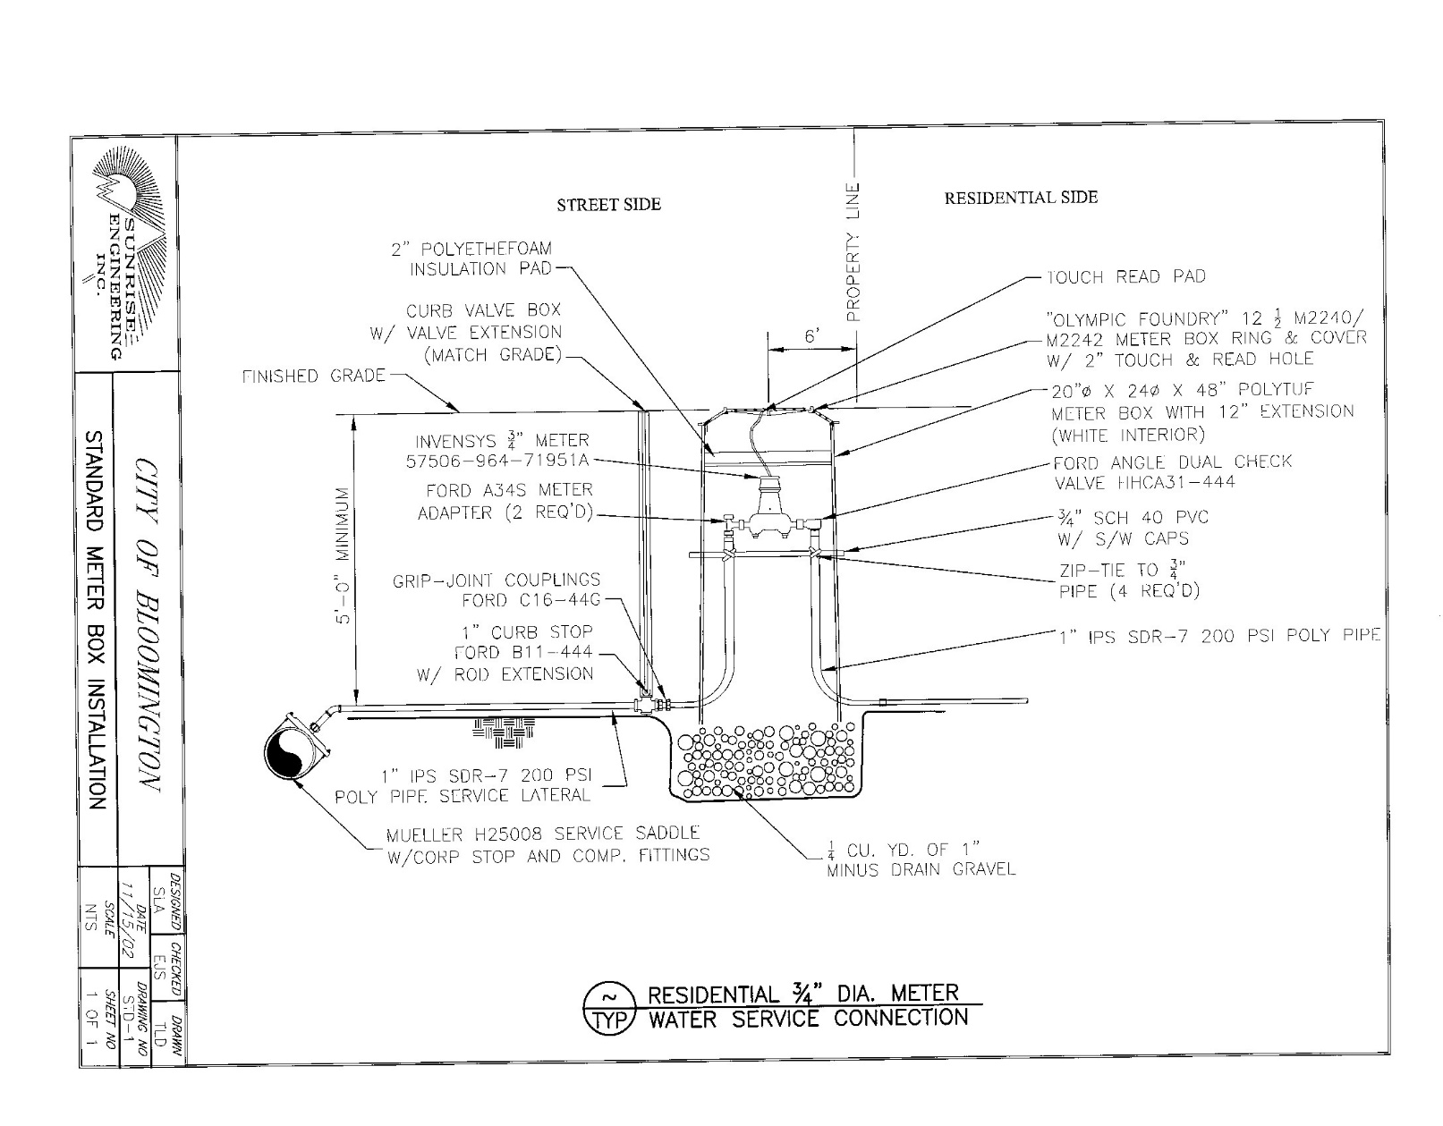

City of Bloomington Water Meter Cut Sheet
“Exhibit A”
Page 2
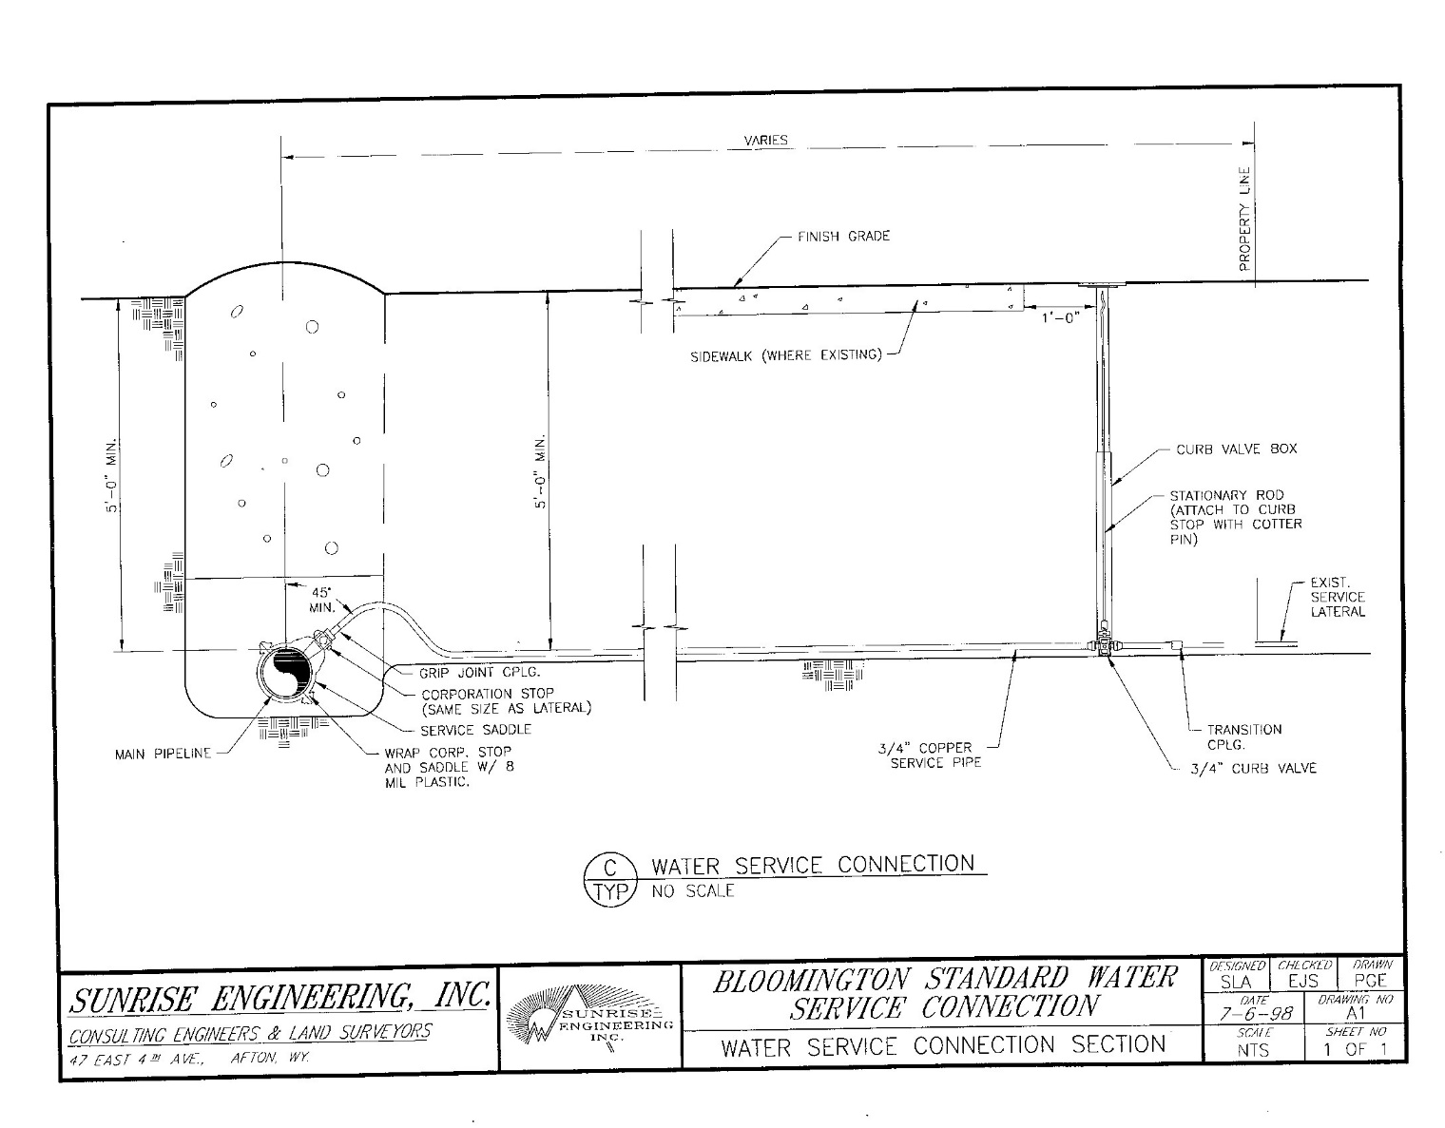

City of Bloomington Sewer Lateral Connection Cut Sheet
“Exhibit B”

